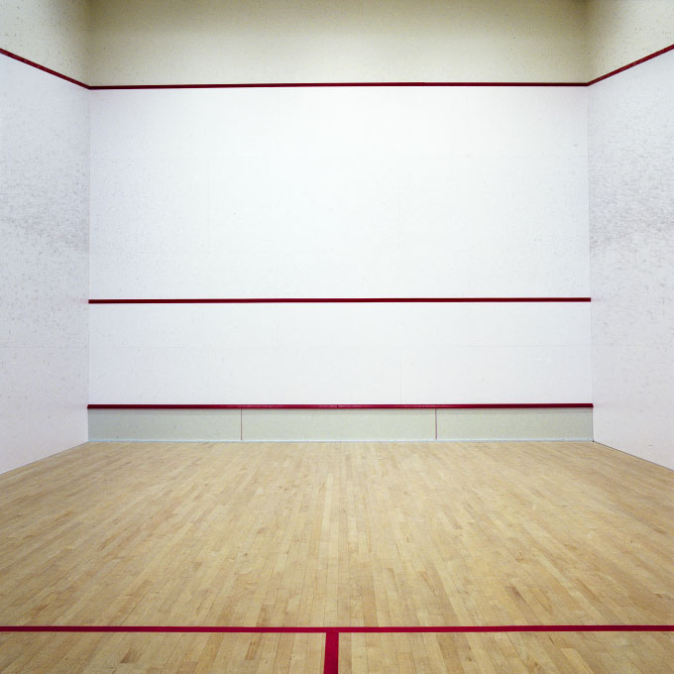
Cascades Club
Squash Open

March 17-20, 2016
***EYE PROTECTION RECOMMENDED ***
Limited Size Draws / REGISTRATION and-or Info
Lars Roberts 819.918.1823 or larsroberts@gmail.com
Registration closes Friday, March 11, 2016

Cascades Club, 100 Chemin De la Rivière, Chelsea, QC.
www.cascadesclub.ca / 819.827.0684

Out of Towners:
Motel La Vallée, Chelsea, 819.827.0524

- Adult $45 / Student (under 26 YoA) $30
- A,B,C,D (Mixed Gender Draws)
- 3 matches guaranteed (Thurs matches for locals)
- Coffee and muffins Saturday/Sunday, Saturday pizza
- Cash prizes and other cool stuff
- (New) Indoor camping for out of towners welcome

